1. Write a program that displays the following table.

|  |  |  |
| --- | --- | --- |
| **A** | **A^2** | **A^3** |
| 1 | 1 | 1 |
| 2 | 4 | 8 |
| 3 | 9 | 27 |
| 4 | 16 | 64 |

1. Write a program to approximate the value of π using the following formula. Use 1.0 instead of 1 in your program
2. 
$$π=4*( 1-\frac{1}{3}+\frac{1}{5 } -\frac{1}{7}+\frac{1}{9} -\frac{1}{11}+\frac{1}{13})$$

3. (*Business: check ISBN-10*) An **ISBN-10** (International Standard Book Number) consists of 10 digits: *d*1*d*2*d*3*d*4*d*5*d*6*d*7*d*8*d*9*d*10. The last digit, *d*10, is a checksum, which is calculated from the other nine digits using the following formula:   
   (*d*1 * 1 + *d*2 * 2 + *d*3 * 3 + *d*4 * 4 + *d*5 * 5 +  
   *d*6 * 6 + *d*7 * 7 + *d*8 * 8 + *d*9 * 9) % 11  
   If the checksum is **10**, the last digit is denoted as X according to the ISBN-10 convention. Write a program that prompts the user to enter the first 9 digits and displays the 10-digit ISBN (including leading zeros).
4. 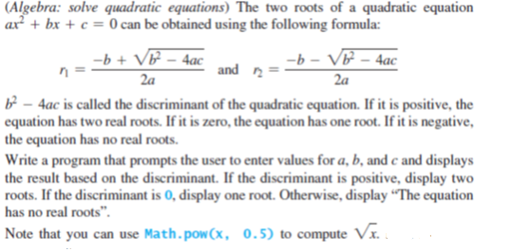df
5. Write a program that prompts the user to enter two points **(x1, y1)** and **(x2, y2)** and displays their distance between them. The formula for computing the distance is square_root((*x*2 - *x*1)2 + (*y*2 - *y*1)2.). Note that you can use **Math.pow(a, 0.5)** to compute square_root(*a*).
6. Write a program that prompts the user to enter three points (x1, y1), (x2, y2), (x3, y3) of a triangle and displays its area. The formula for computing the area of a triangle is   
   s = (side1 + side2 + side3)/2;   
   area = square_root(s(s - side1)(s - side2)(s - side3))
7. 